**Project Deployment**

**Github link:** <https://github.com/rkr5b/Project>

**Project URL:** http://localhost:8080/adexp1/

**User Manual**

**Introduction:**

Ad Express is a web application which can advertise any kind of web applications .With this web application members can advertise their ads to world at free of cost. With this application it can attract buyers all over the world. It is a simple application.

This application is organized using an easy-to-follow **index** .By using this index we can find required ads quickly and easily. I hope that this application will grab people attention. Because of its uniqueness I hope visitors will make this site as bookmark in their browser.

I am very pleased to offer you free classified advertising over the Internet. We can find menu options at home page. These allow you to go straight to a category you want by navigating through the sub options. There are three persons involve in this application. They are Admin, Member, and Customer.

**Admin:**

Here admin has complete control over this application. He can add, edit members details as well as advertisements details.

**Member:** To post an advertisement member has to register first. After completing registration then he can post advertisement. Member can post any kind of advertisement through this site.

**Customer:** Customer can view advertisements which are posted by members. If they want to get any information regarding advertisement they can approach members of that advertisement by clicking on that advertisement.

**Error recognition and Handling:**

At registration page in order to register member has to enter all required fields which are specified by using ‘*’ symbol. Otherwise it displays following webpage with errors. It shows that login is required, password is required, name is required, and Email id is required.

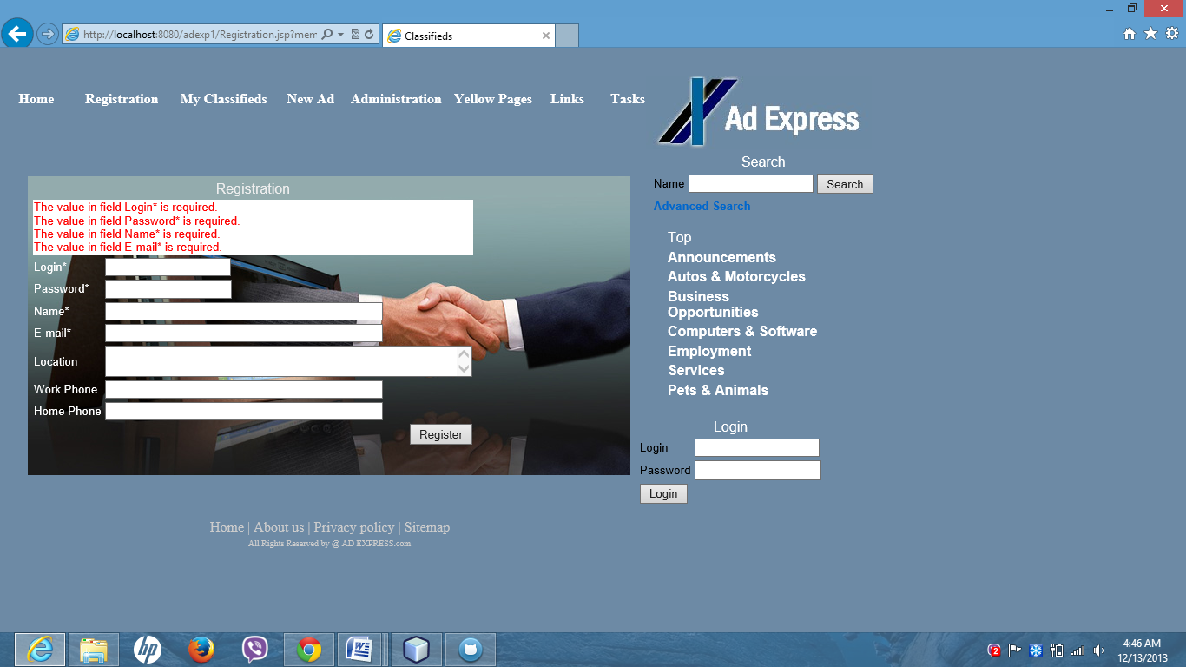

If Login field already exists then it displays following webpage with errors. Like Login field exists already.

. 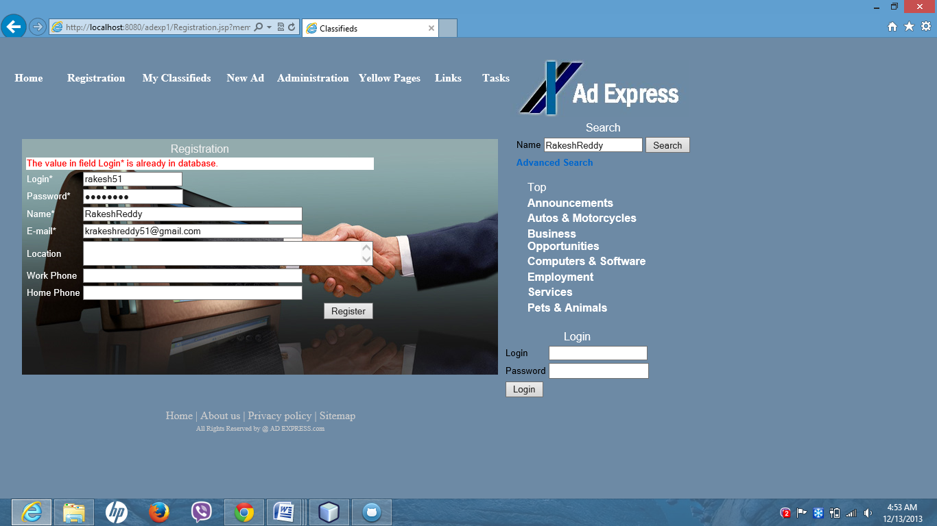

The following one shows the homepage of my web application.

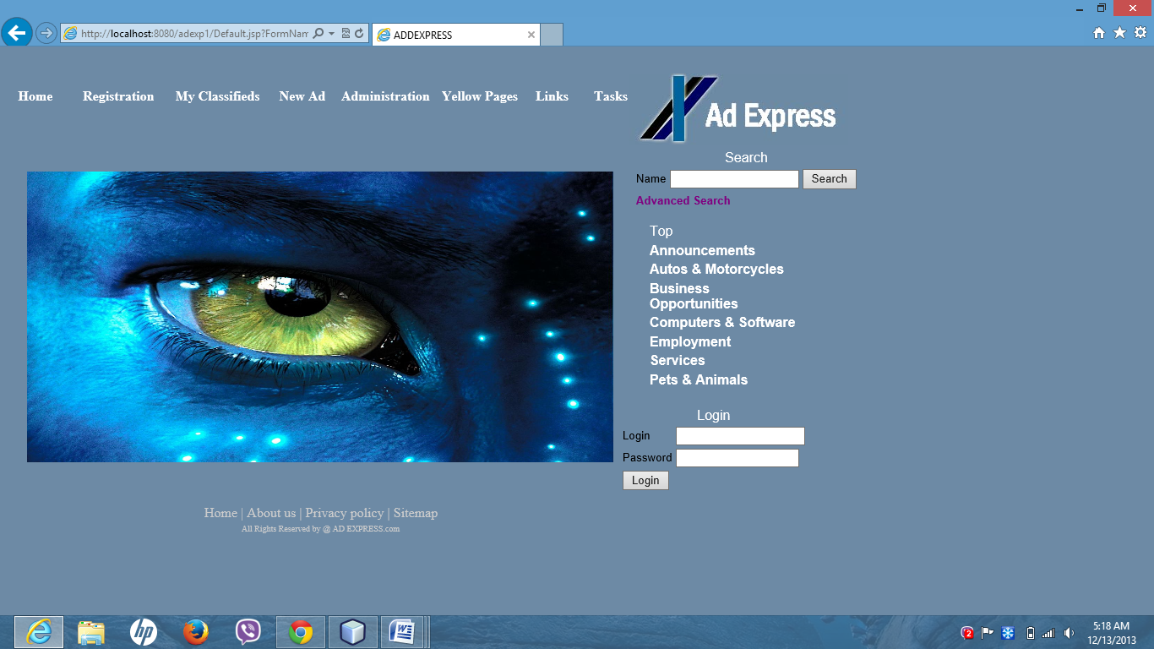

If anyone wants to post any advertisements they should register first. The below webpage is registration page.

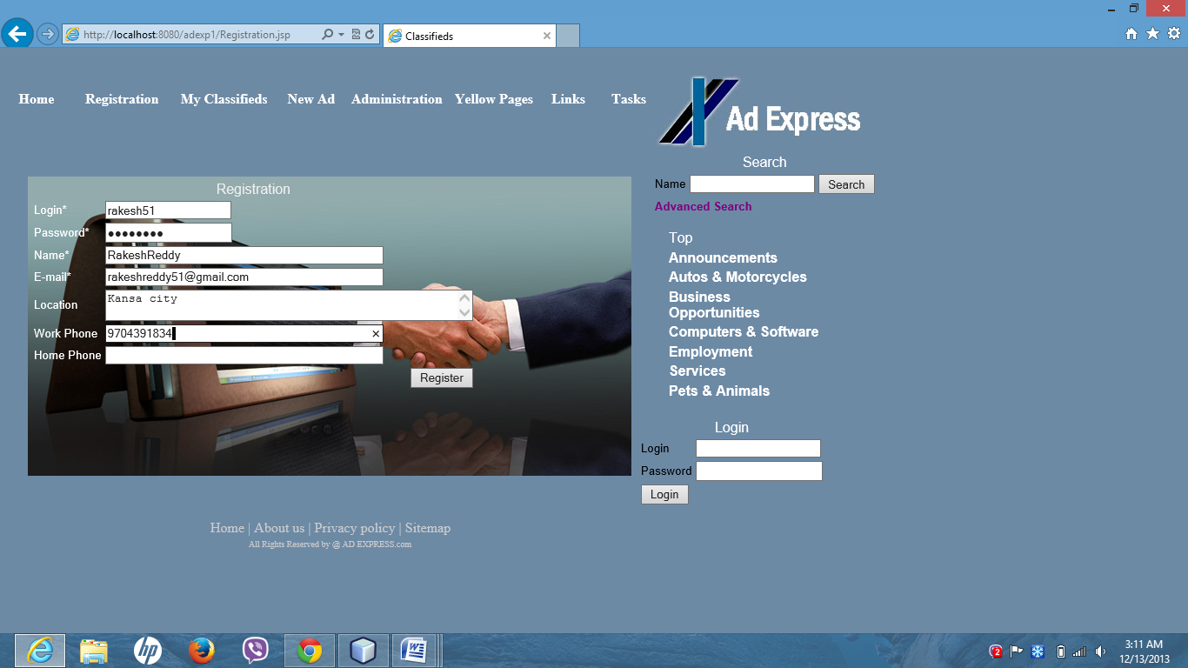

After completing registration members need to login to post any advertisements.

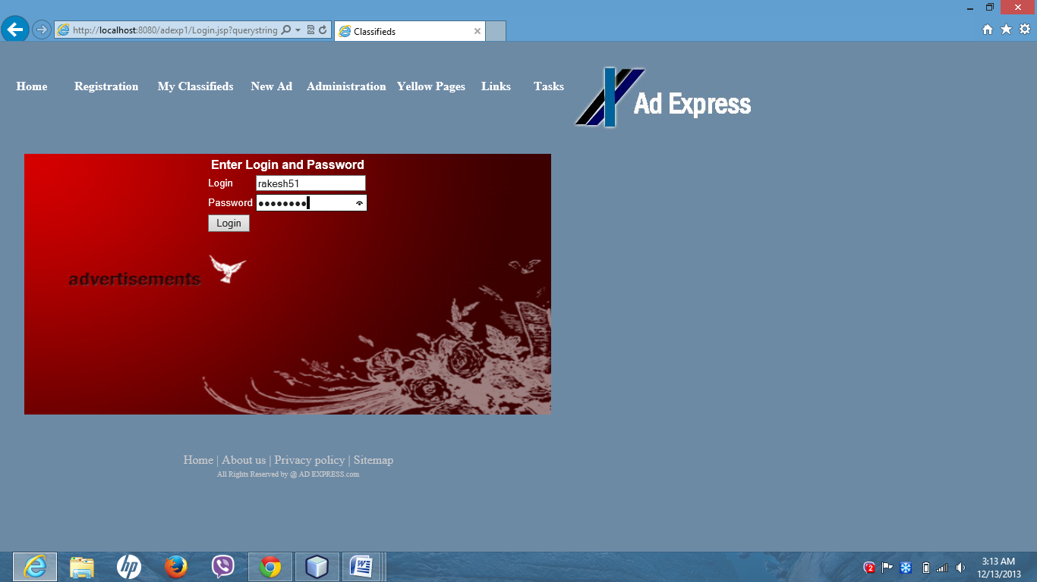

After logging the following web page appears. It shows that no records are there. advertisement just click on **New Ad**.

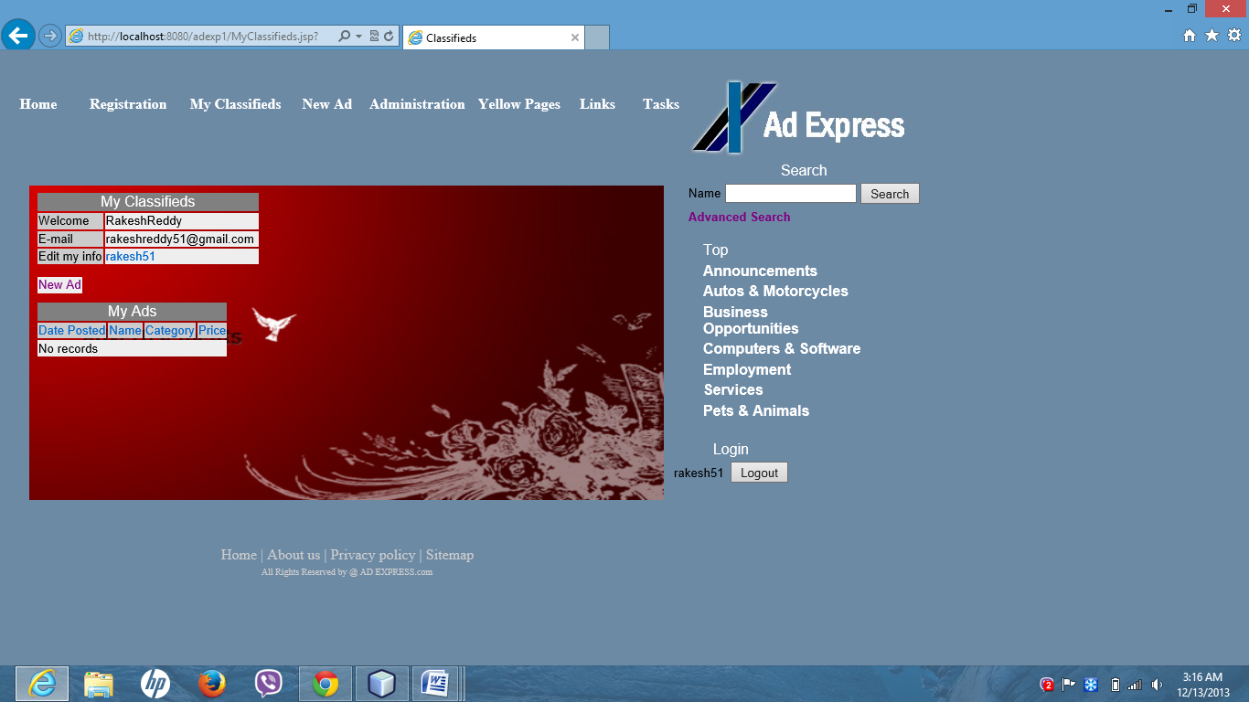

To post a new advertisement just click on **New Ad**. Then the following webpage appears.

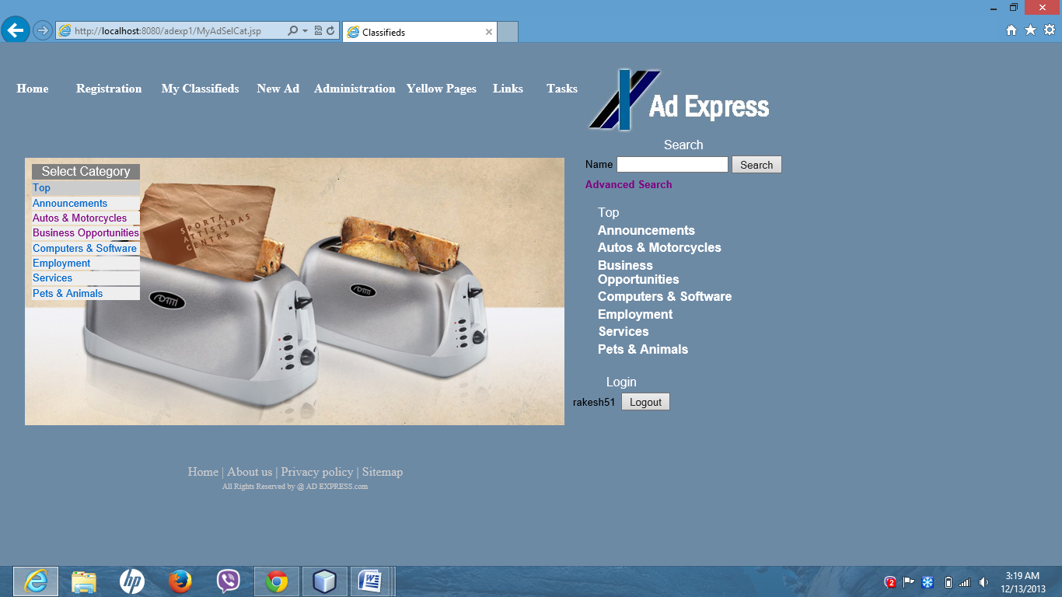

It shows that in which category you want to post advertisement. Then select one of categories .If we select Autos & motor cycles, then the following web page appears.

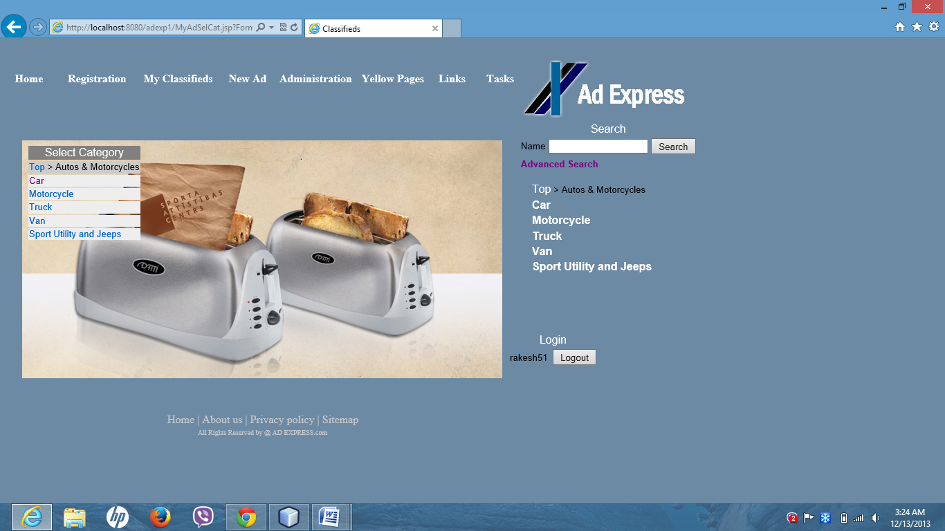

In that category just select to which one you want to post advertisement. I just select car, it asks you to enter following details.

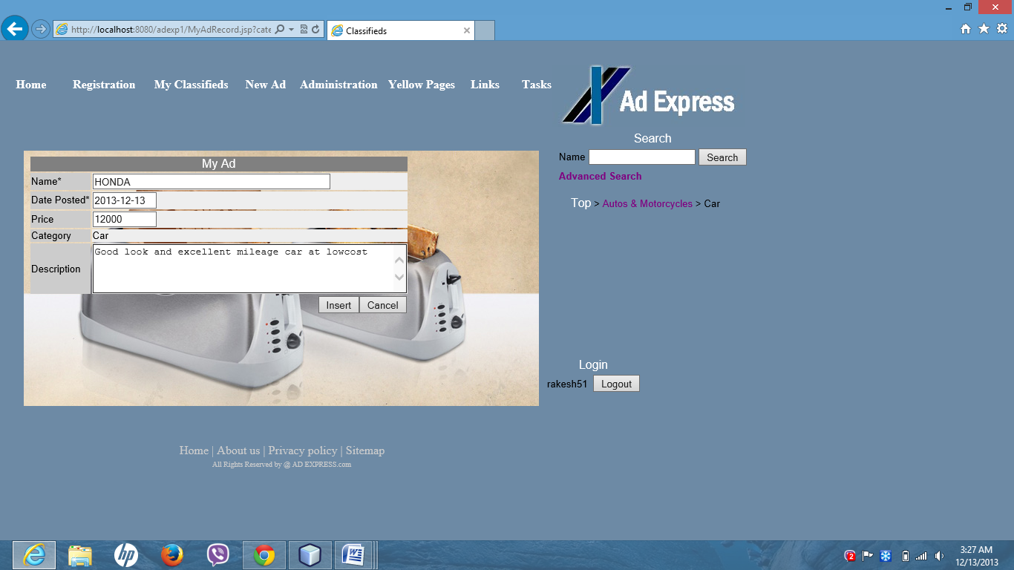

After inserting data it displays following webpage and it shows ads related to that person or company.

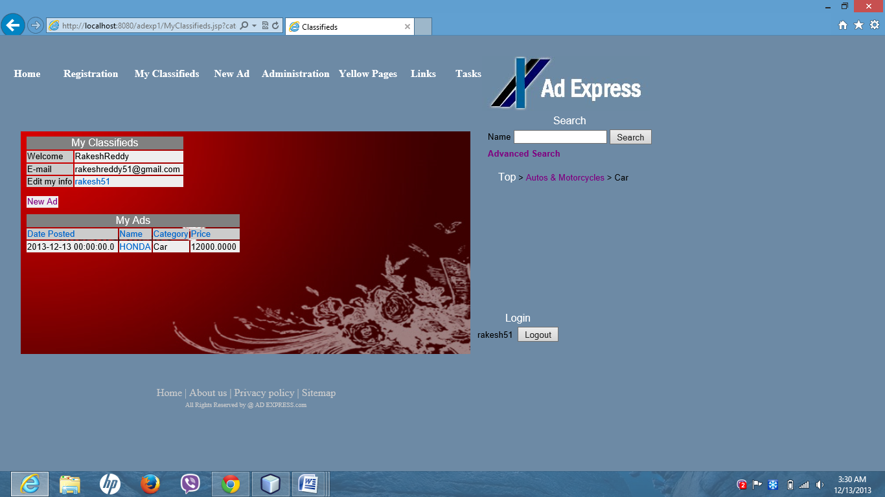

If member wants to post ad regarding computers and software in category section just click on computers and software then it displays following webpage.

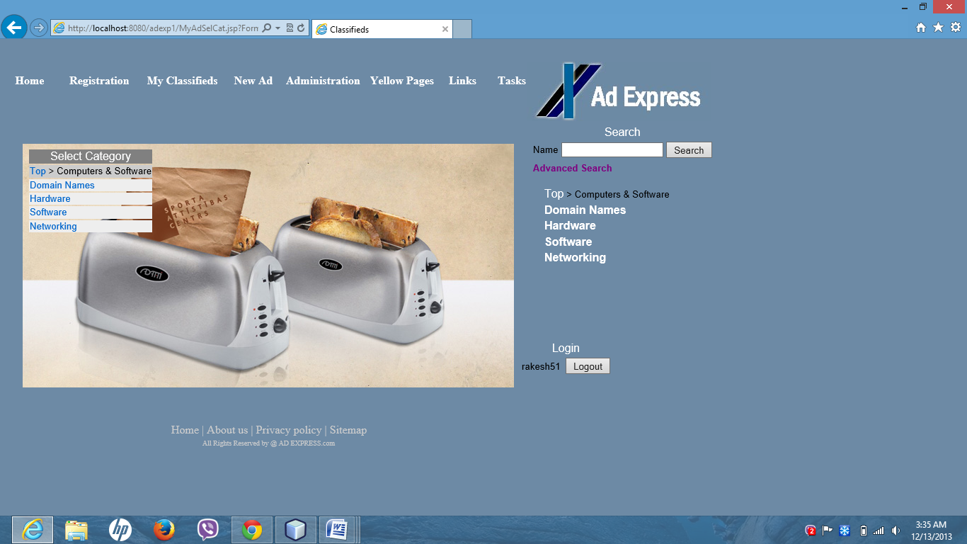

After clicking on computers and software it displays below webpage to select options.

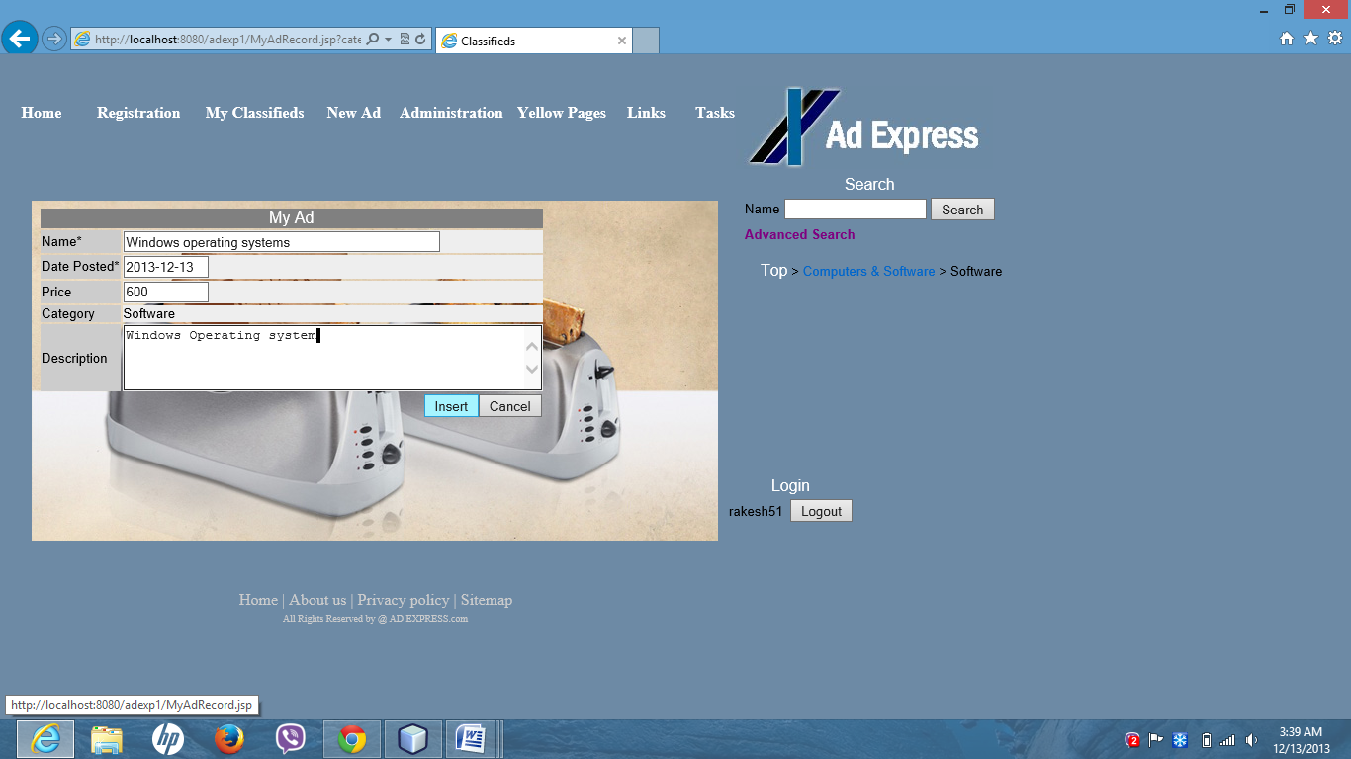

After inserting data it displays following webpage. Here it showed all advertisements related to particular member.

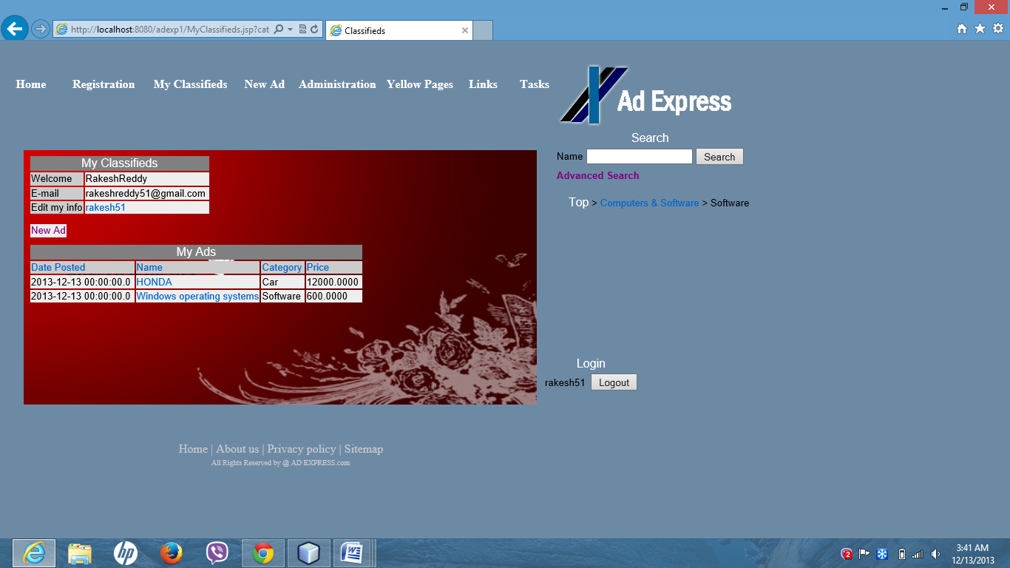

If they want to post an advertisement regarding buying and selling of particular animals they can post advertisement through this site. At home page under categories section there is pets and animals’ option is there. Just click on pets and animals category. Then it displays following webpage.

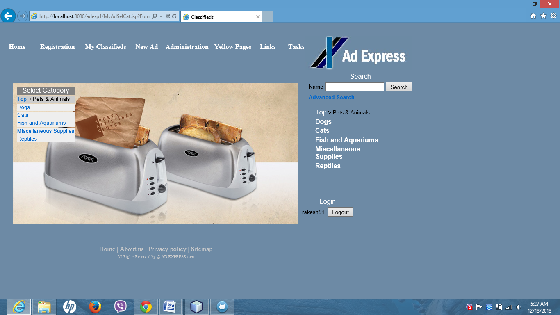

Under this select animals like cat, dog or anything. If I select fish and aquariums it displays following webpage.

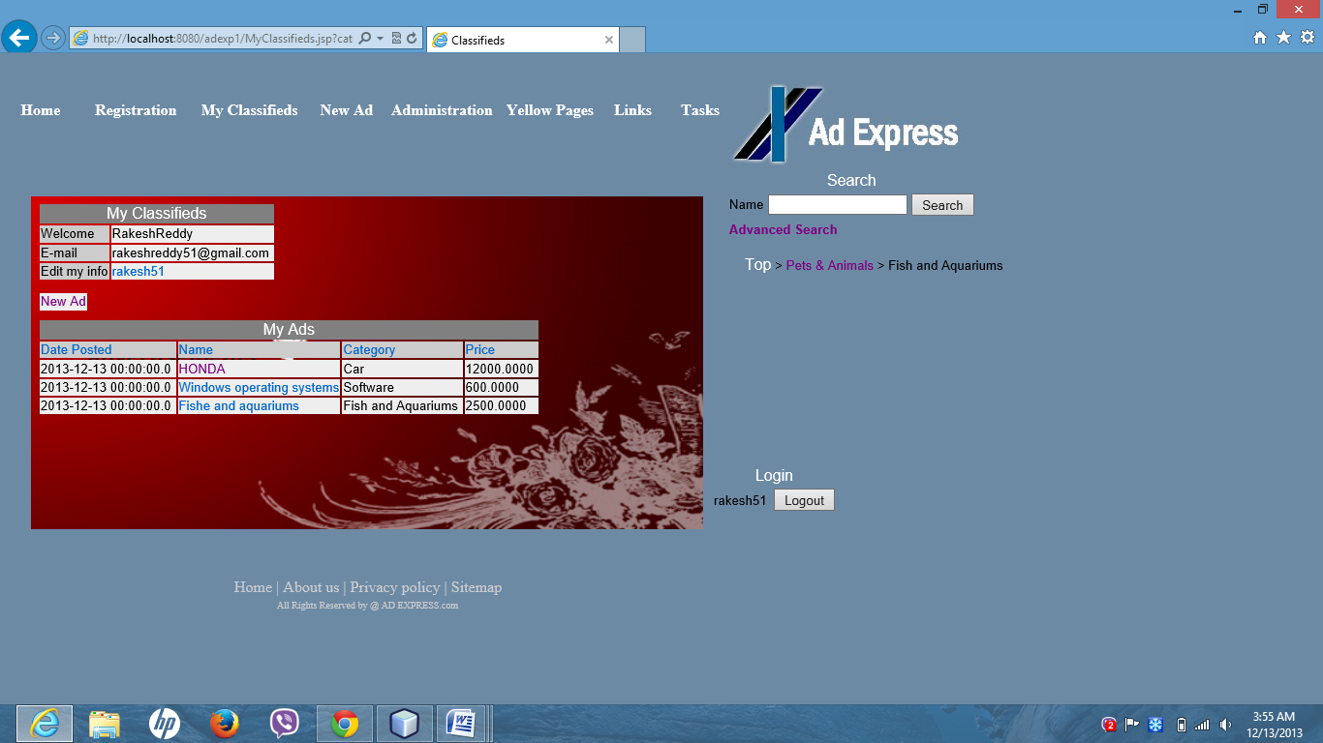

If we want to post ad for services then select services under categories, then it displays following webpage.

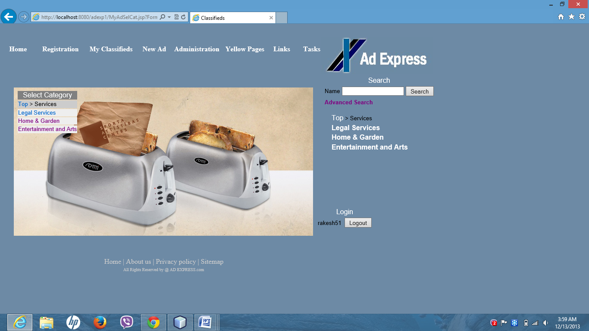

If I select Entertainment category then it displays following webpage.

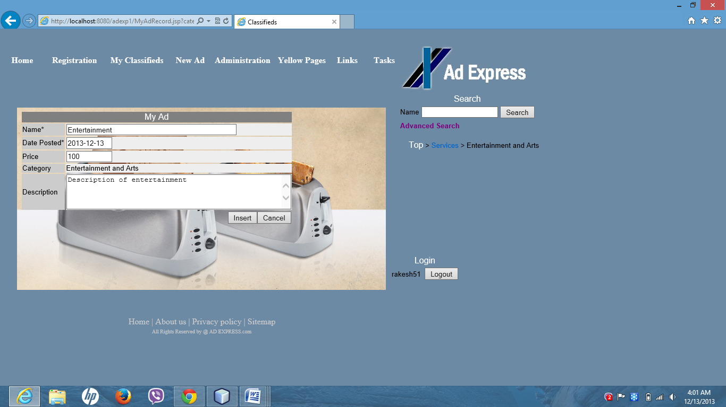

After inserting data regarding advertisement it displays following webpage.

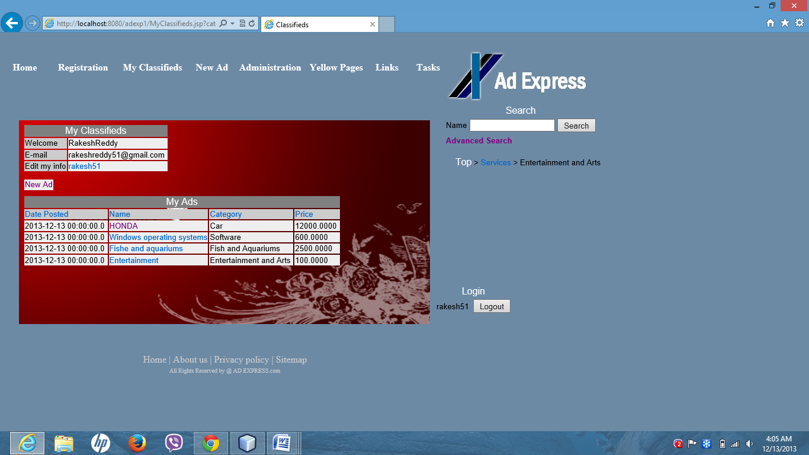

Likewise we can post any kind of ads to this site.

If member wants to see all his published classifieds there is My classifieds link at home page .If he click on My classifieds link then member can view all their ads and he can edit information regarding ads and member information.

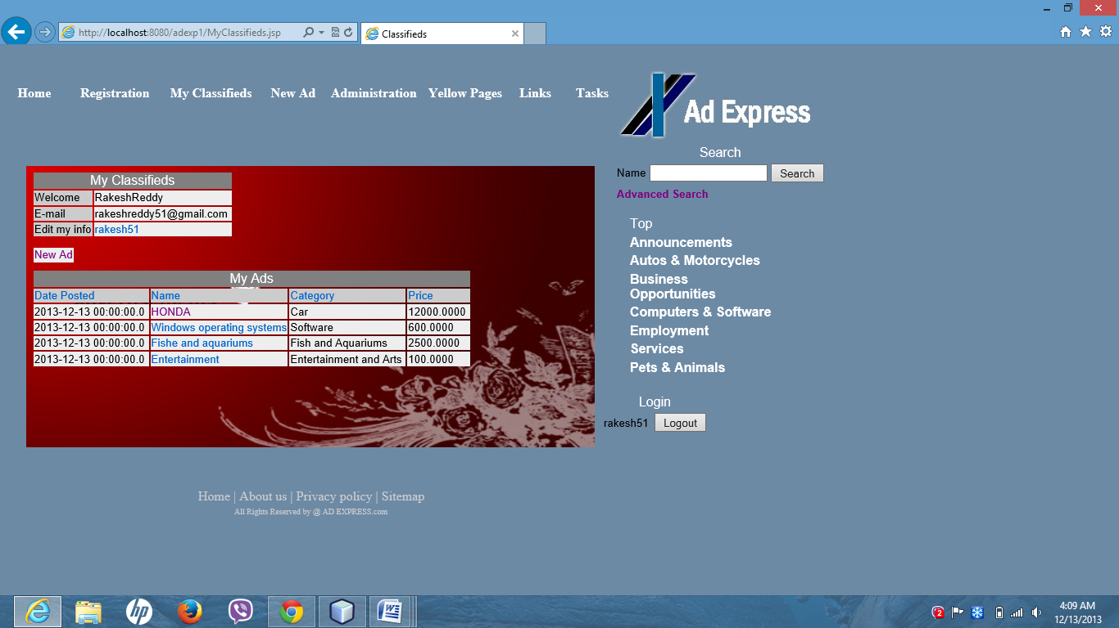

Admin can have control over this site. At home page administration link is there. By clicking on Administration it asks to enter login id and password.

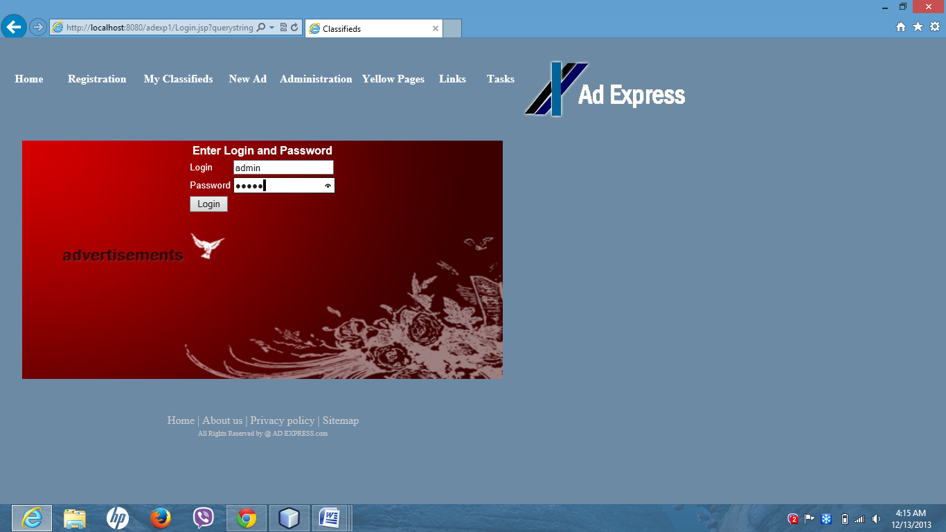

After logging as administrator it displays following webpage. And he can view all members and categories.

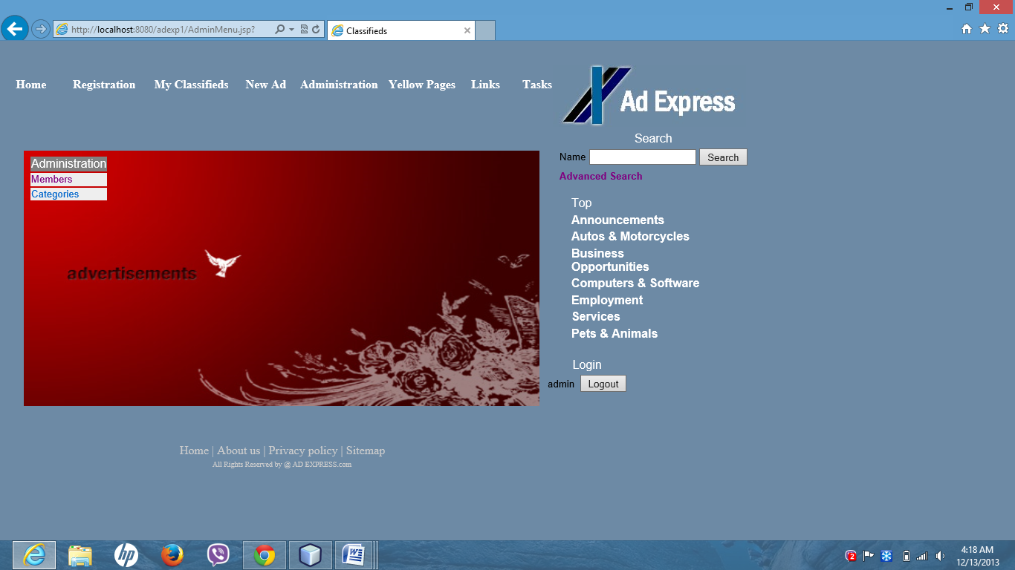

By clicking on he can view all members info .Admin has permission to edit or delete members information including admin info.

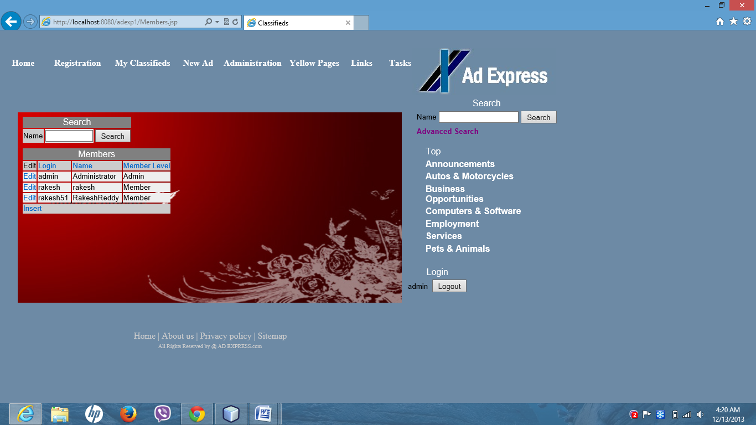

Admin may search for any member information using search button.

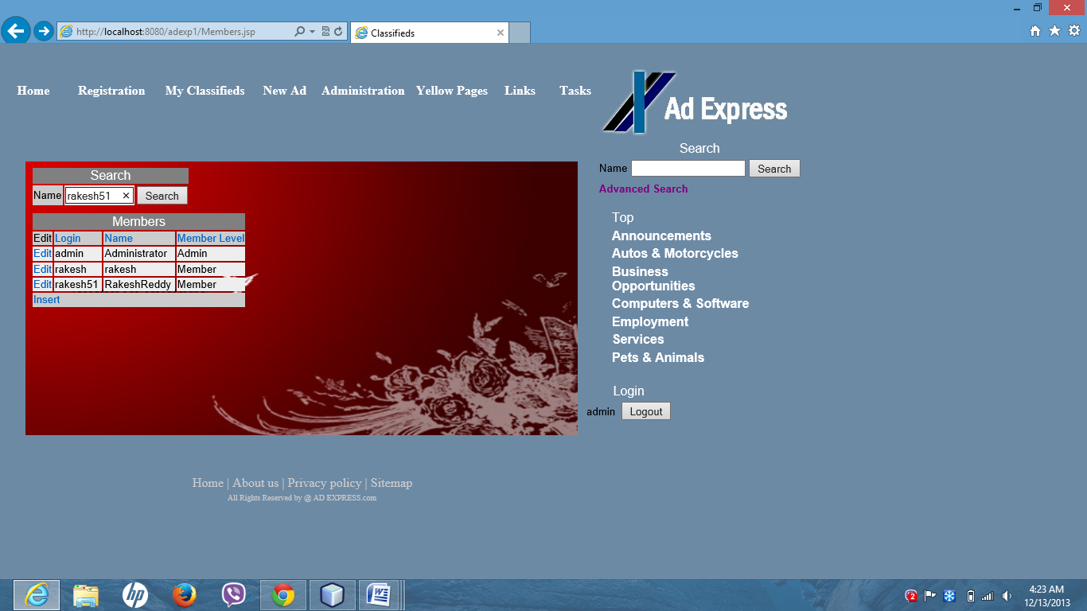

After entering members name then admin can view members’ information.

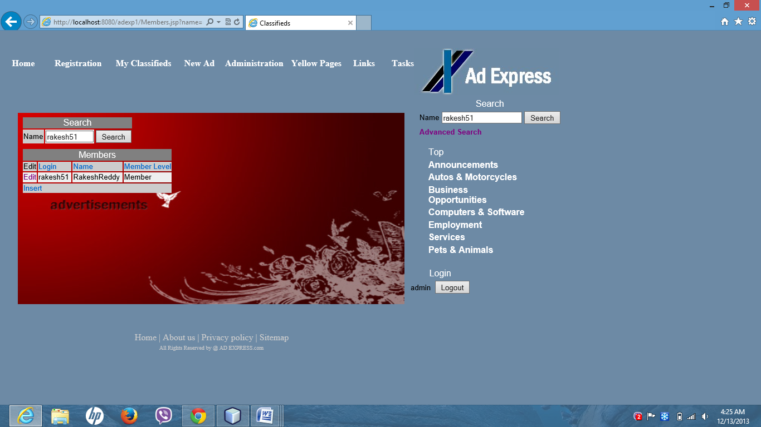

Admin can view categories info by clicking on categories.

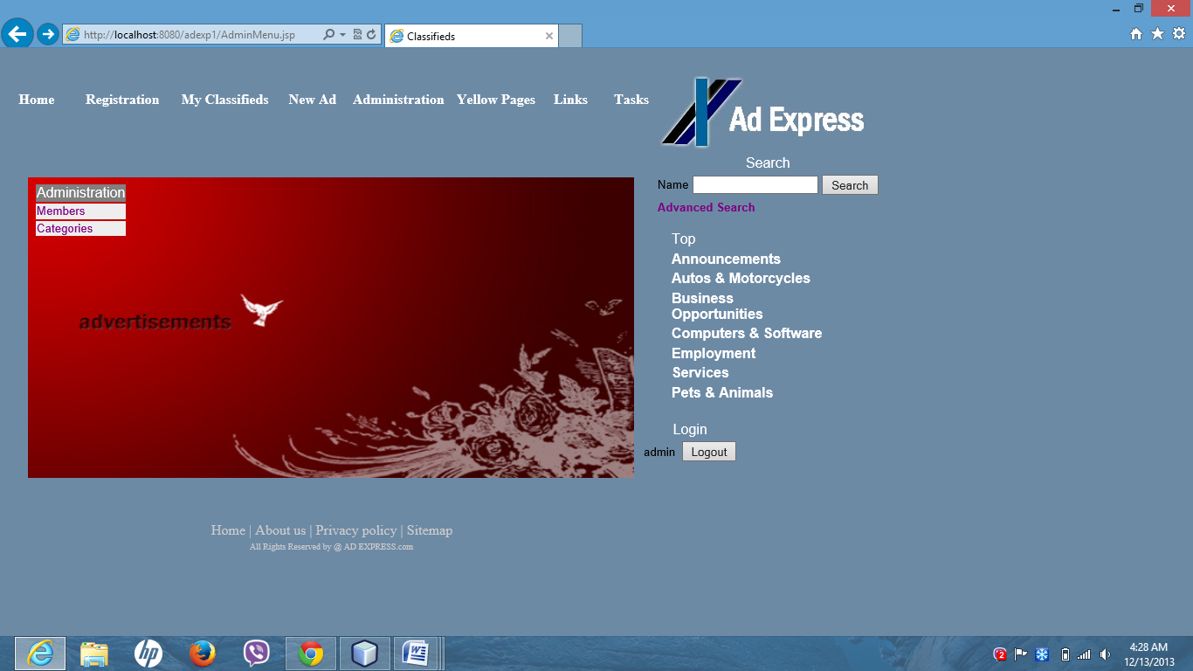

After clicking on categories it displays below webpage which can shows all categories information.

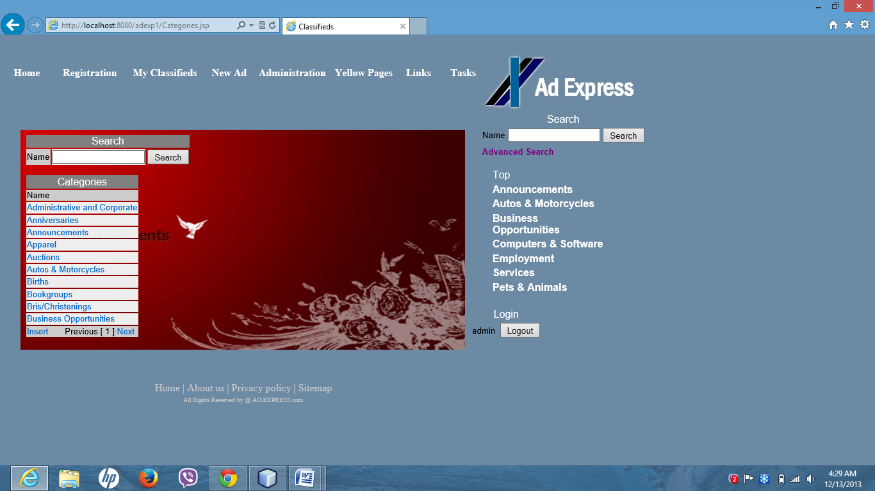

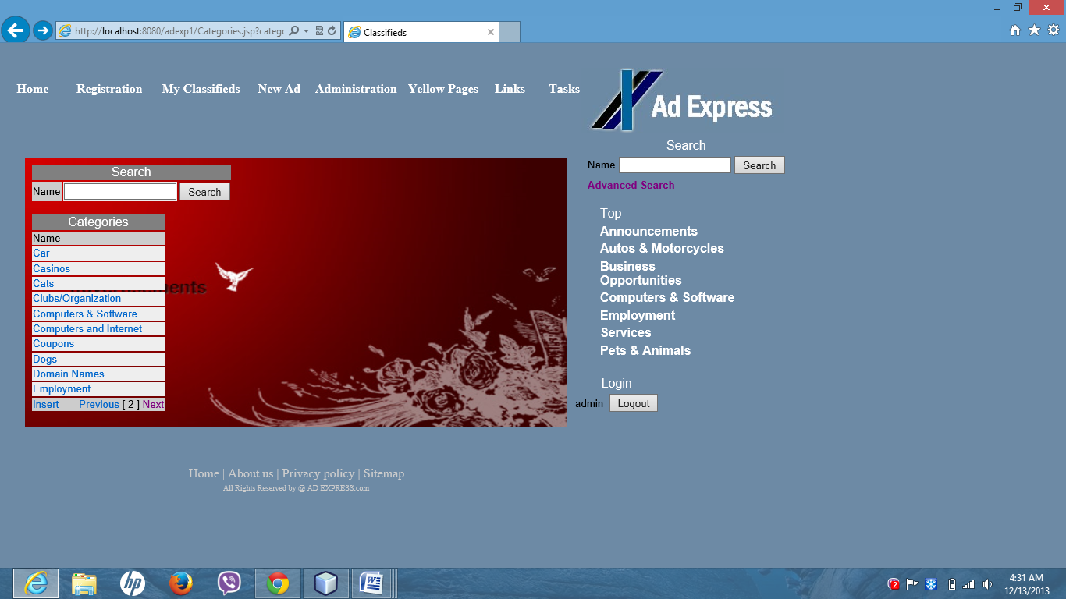

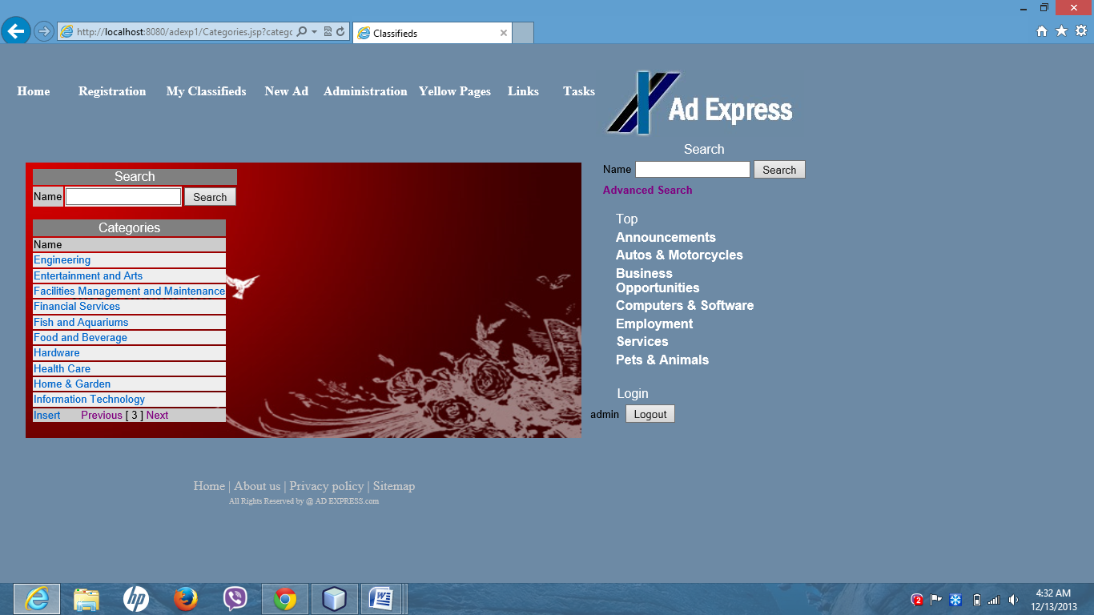

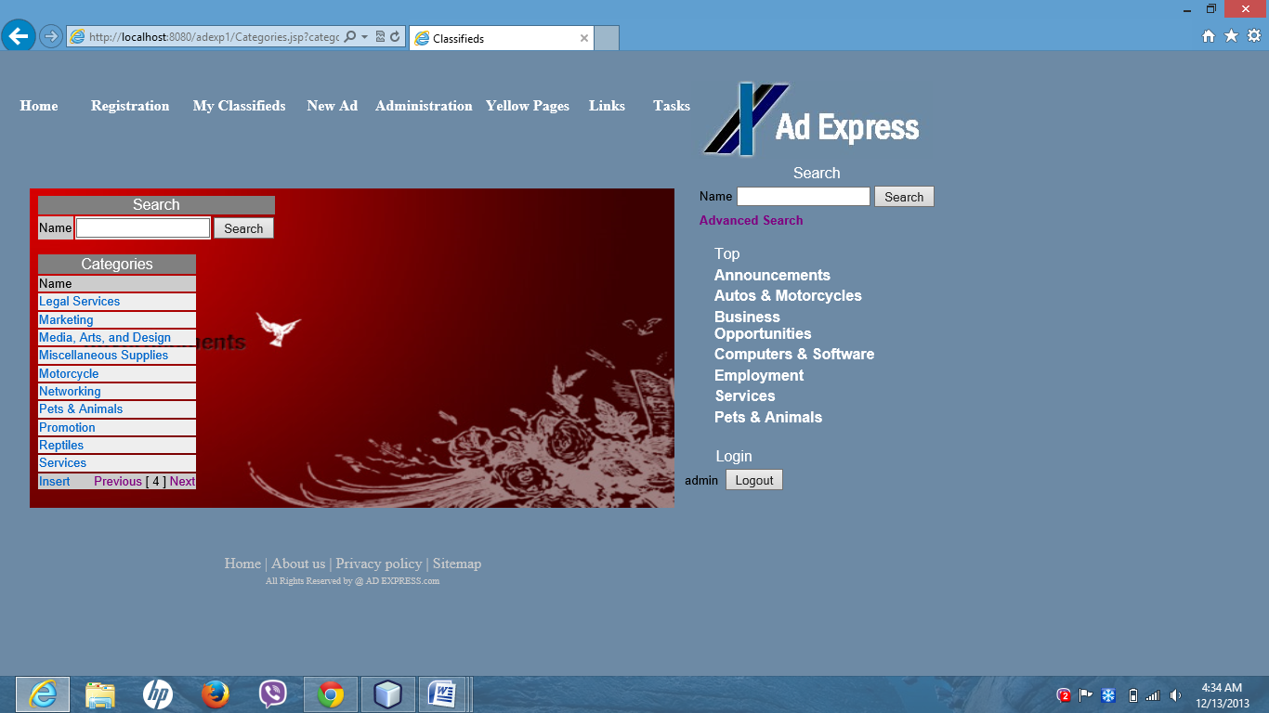

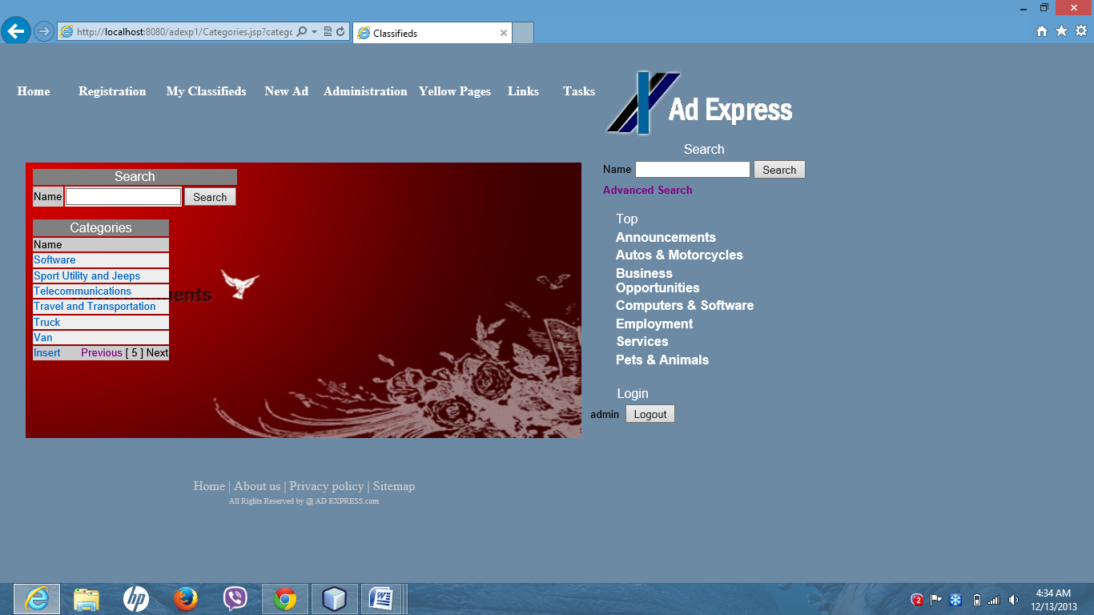

Customers can view ads by using search button. Here they will enter required information.

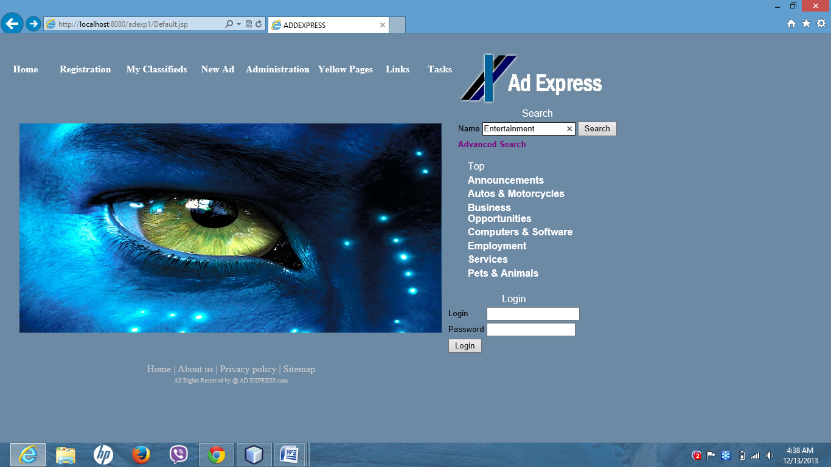

After entering this information following web page appears.

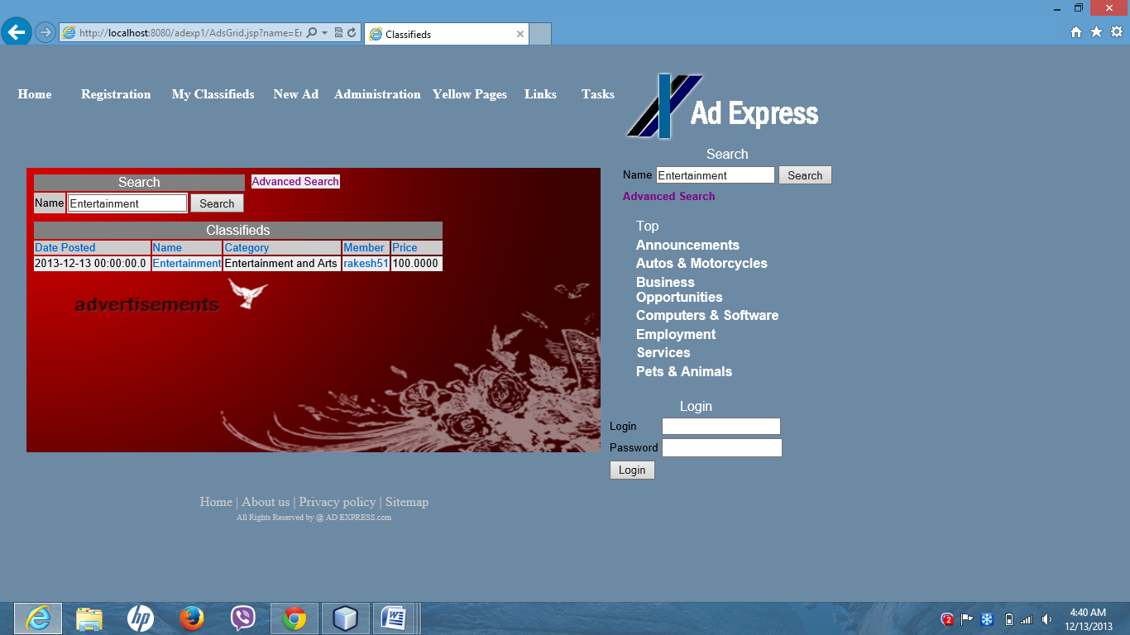

By clicking on that advertisement it provides complete information regarding that advertisement.

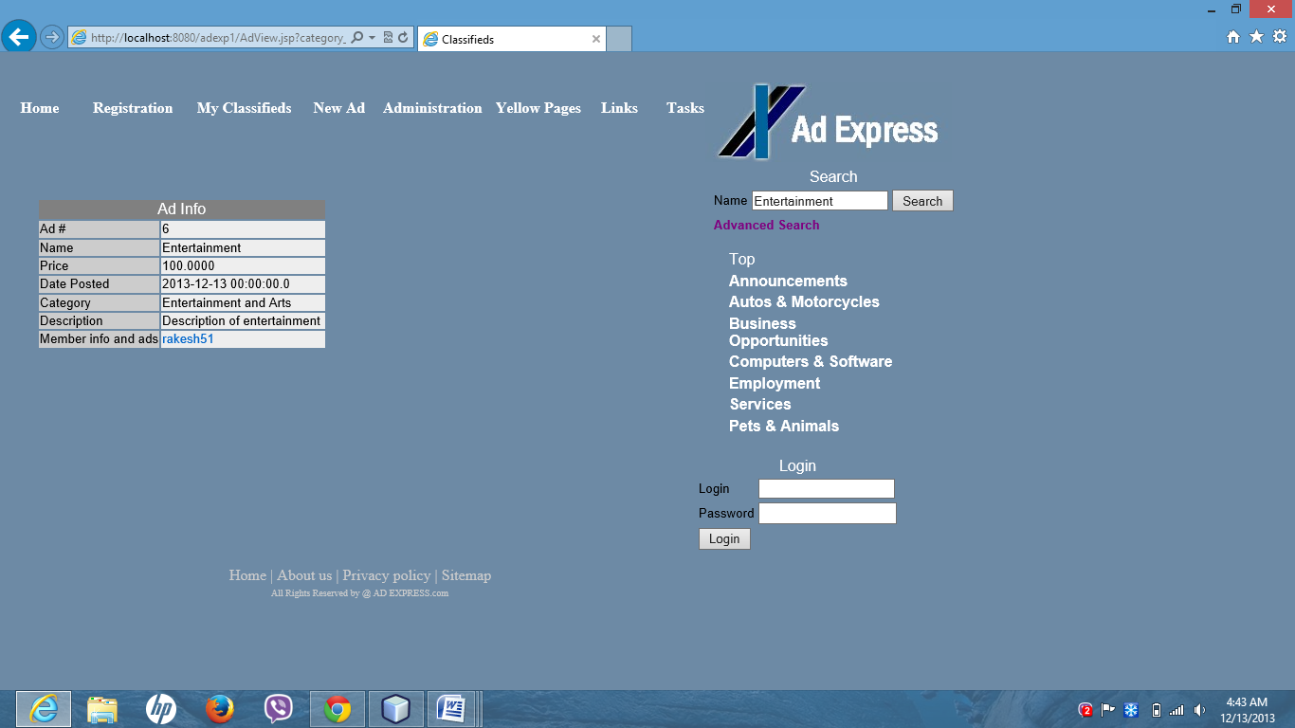

Customers can contact the member by clicking on Member name.

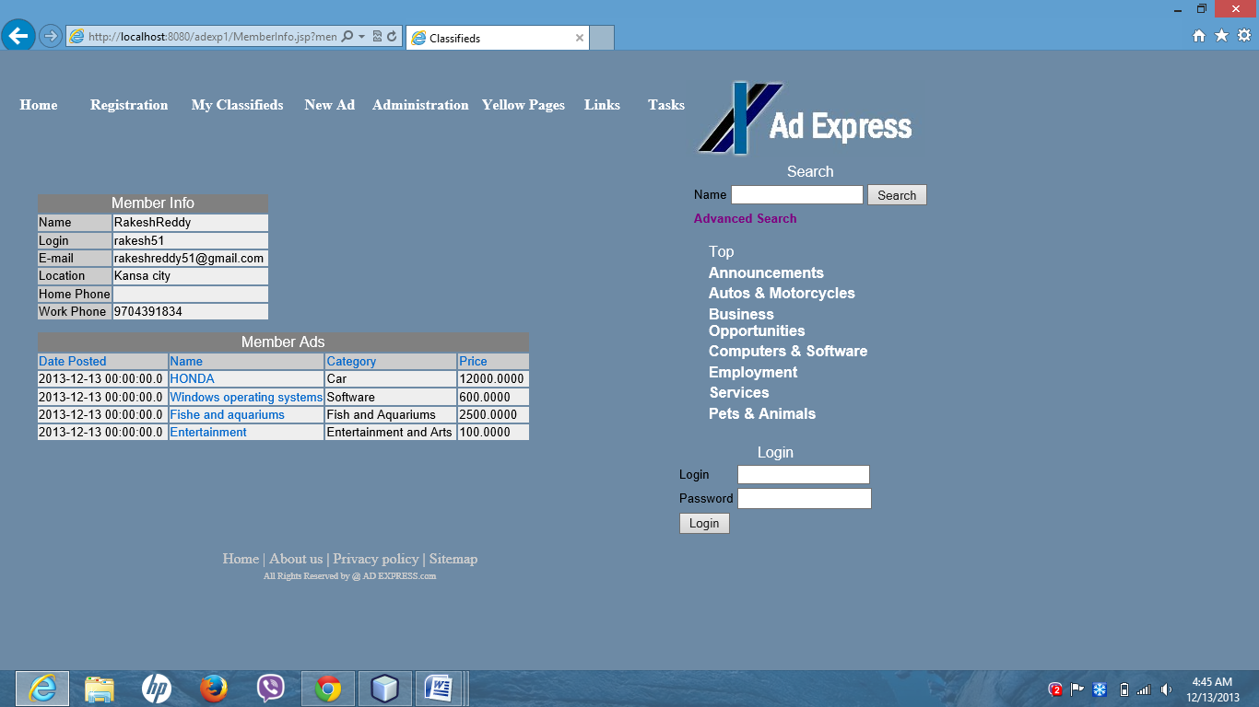

Customers can also search for ads by using advanced search at home page.

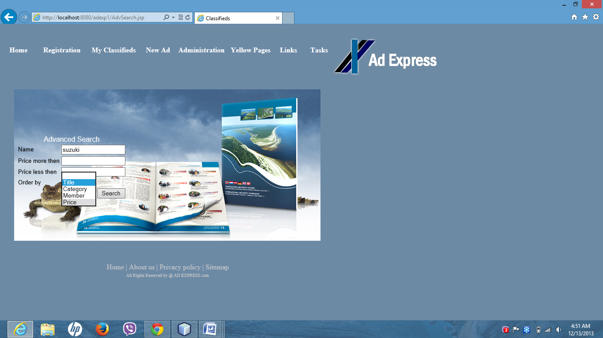

Then it displays information regarding that advertisement.

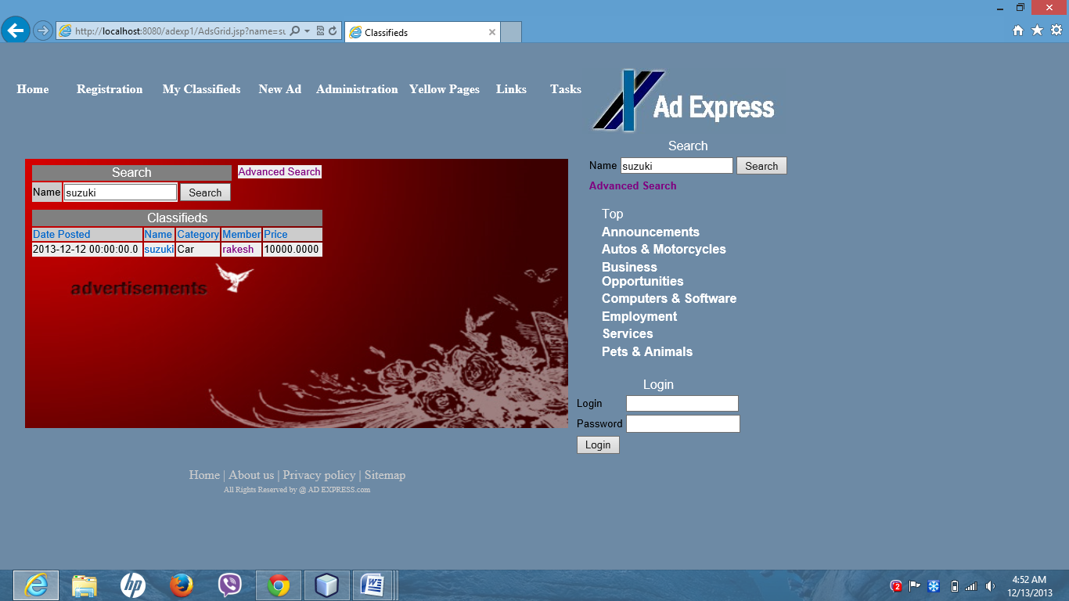

If they click on search button at home page it displays all advertisements information.

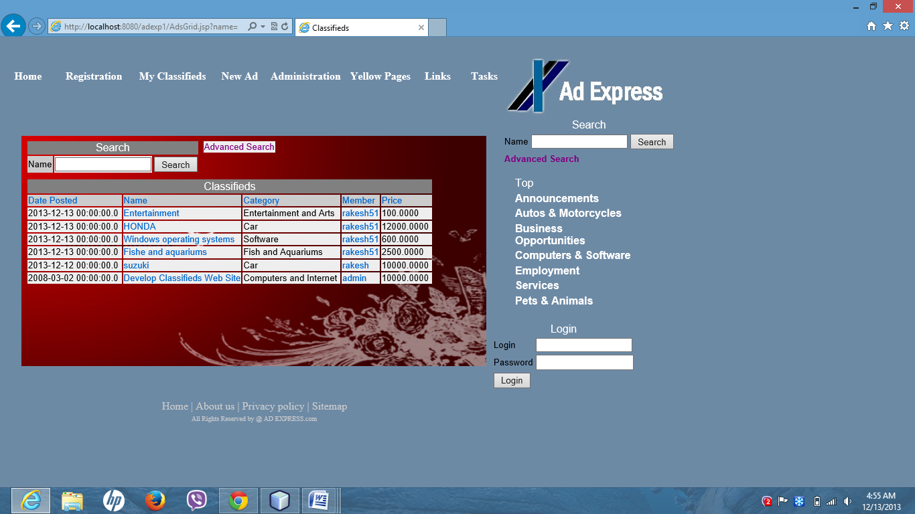

It also has yellow pages link at home page.

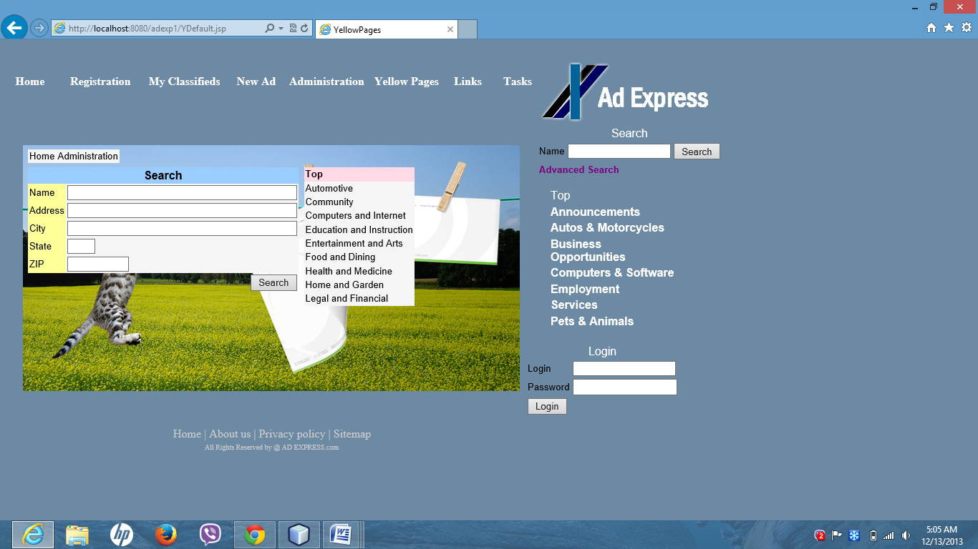

Here so many categories are there .If you search for computers and internet then select computers and internet.

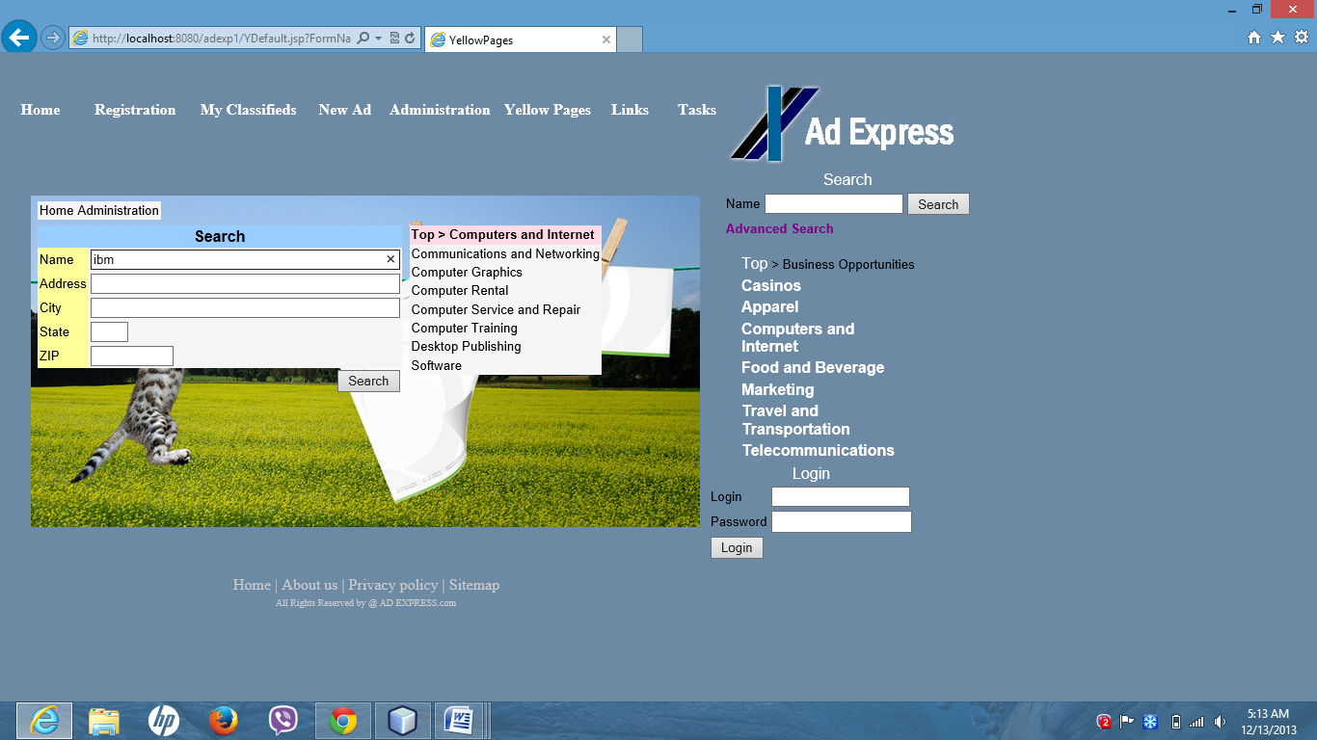

In search if we type IBM it displays some information regarding IBM.

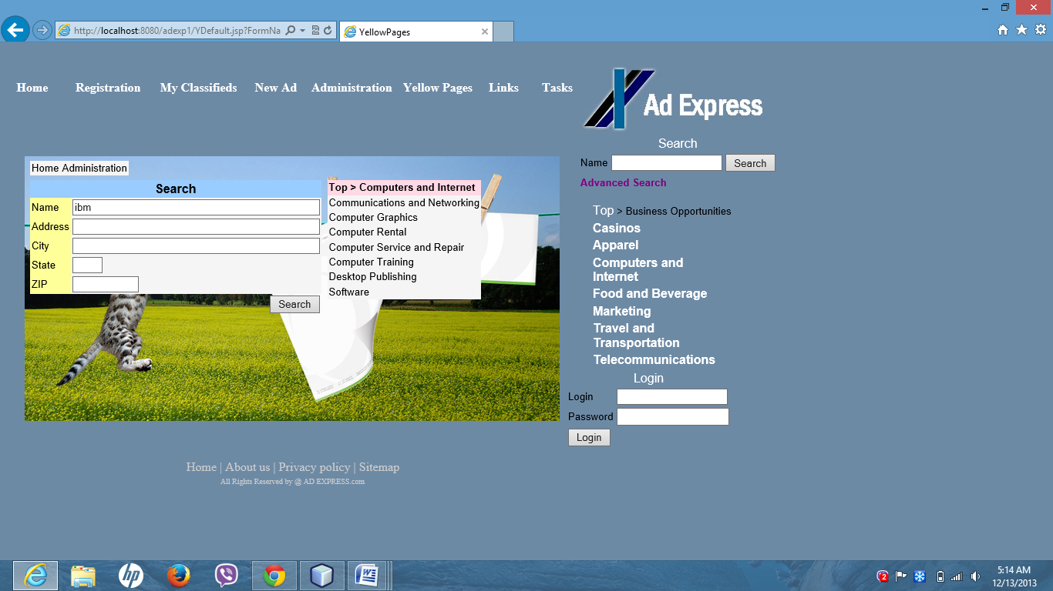

Then it displays following webpage with IBM information.

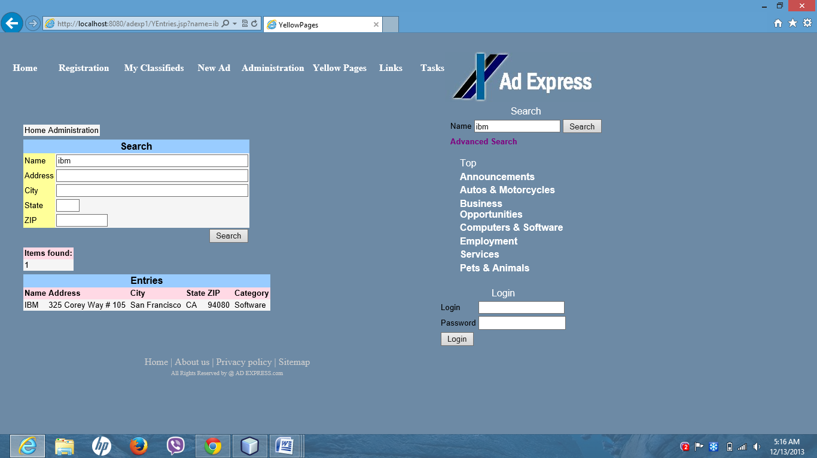

**Project Management**

**Github:**

Github is an important agile website which all the files can be stored in a single

repository and can be made access to others. Because of this I can use my code anywhere. We can just

download the code form github and use that code. The following screenshot represents files available

in Github site.

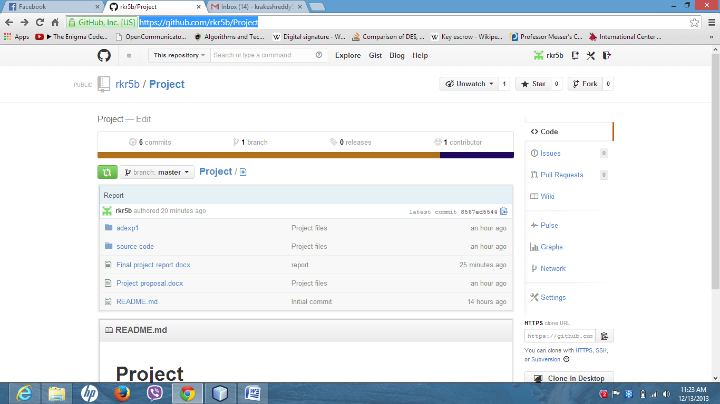

**Github Link:** <https://github.com/rkr5b/Project>

**Final Project Evaluation**

I have done my best to implement all these functionalities. But due to lack of time and my health conditions I was unable to implement some other features. I alone did this project. Really it was a big challenge, when I started developing this project I faced so many bugs and functionalities did not work properly. To overcome those problems I watched so many Java tutorials. Really it took lot of time for me to develop this simple application because I had to concentrate on designing part, documentation part, development part etc. But I learnt a lot while developing this project.

* **Project members evaluation**

|  |  |  |  |
| --- | --- | --- | --- |
| Content | Member | Contribution | Total |
| Project Development (80%) | Rakesh Reddy Kondakindi | 100% | 100% |
|  |  |
|  |  |
| Final Submission (5%) | Rakesh Reddy Kondakindi | 100% | 100% |
|  |  |
|  |  |
| Video Production (8%) |  |  | 100% |
|  |  |
|  |  |
| Others (7%) | Rakesh Reddy Kondakindi | 100% | 100% |
|  |  |
|  |  |
| Overall Contribution | Rakesh Reddy |  | 92% |
|  |  |
|  |  |